1. initialize project--npm init -y

2. install the libraries

express, jsonwebtoken,dotenv

3. js file created for secret tokens

4.--save-dev nodemon for us to refresh our server

5. Creation of script to help start our server using nodemon

6. npm run devStart to run the development environment

7. testing in server.js

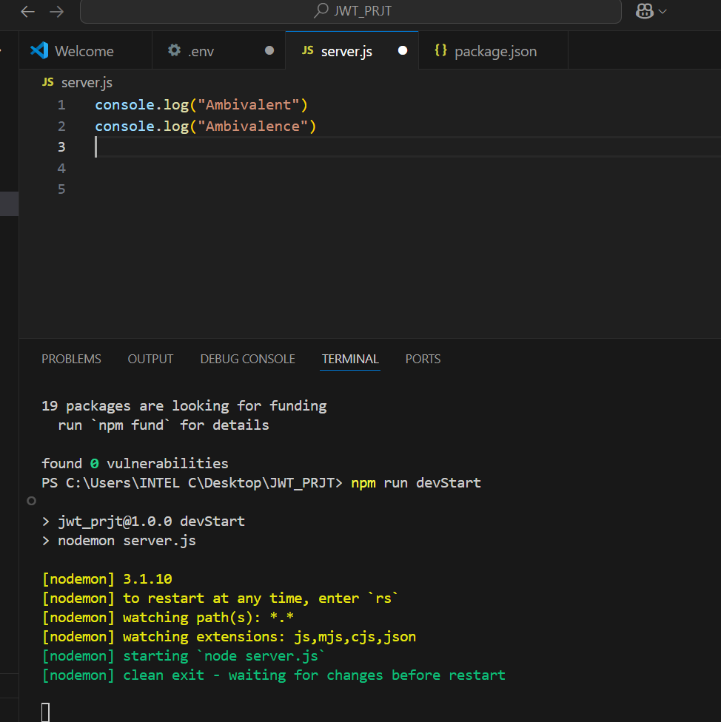

Package built before for importation of new functionalities

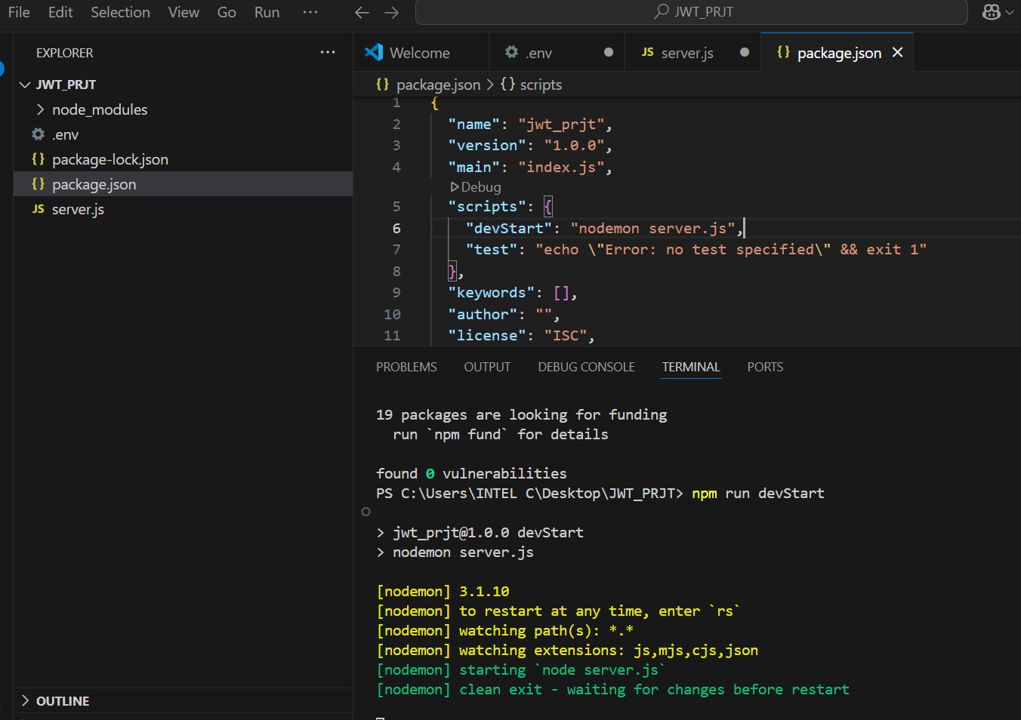

const express = require('express')//require express libraray

const app = express()// call the express using the app variable

 app.listen(3000)//app listening through port 3000

///creation of Posts status

//Note server restarting

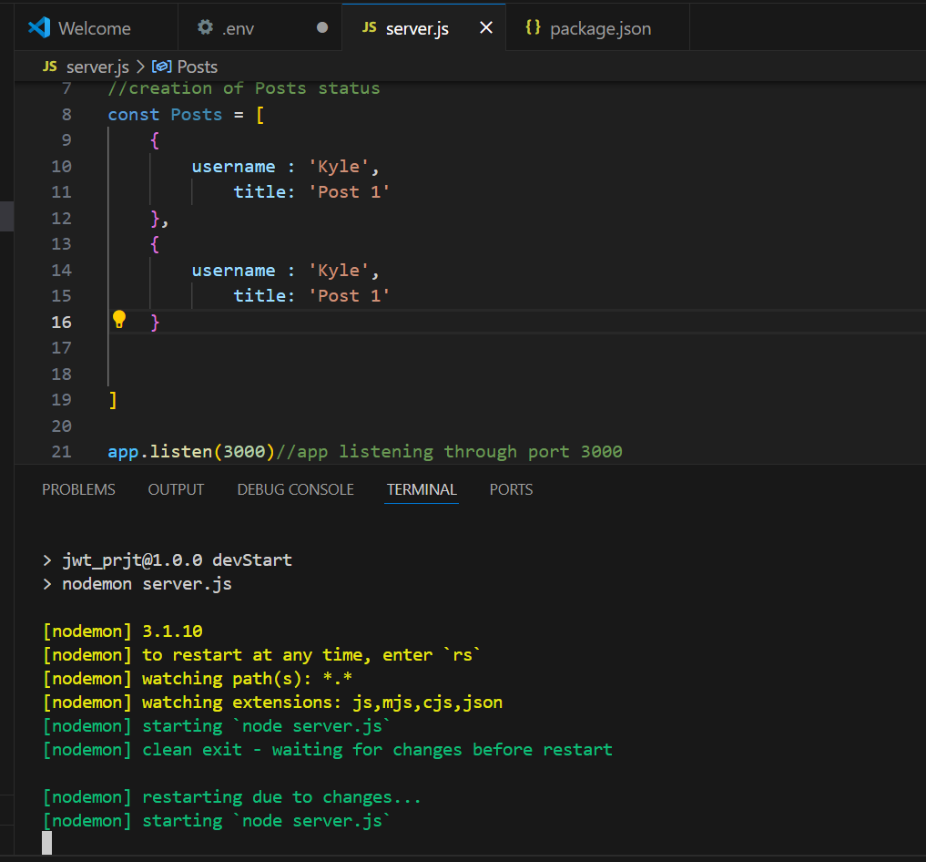

Under the REQUEST.REST tab created a new file to get the host 3000

<http://localhost:3000/posts> unable to resolve url

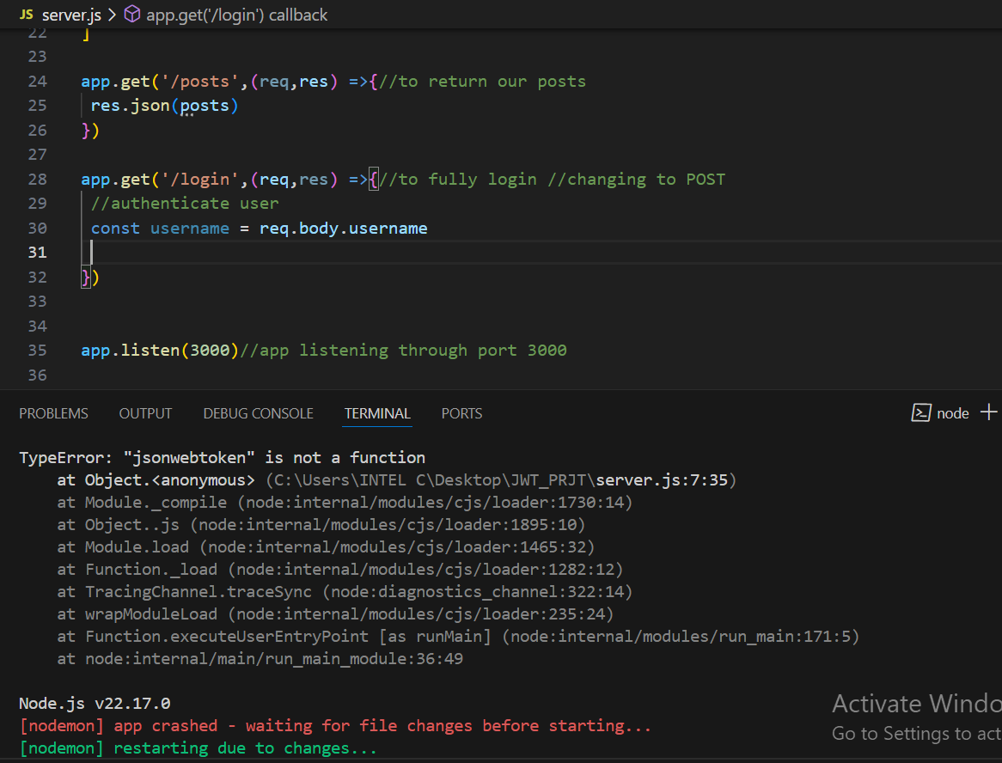

Still having the same issues

Random list of characters generated for Access Token

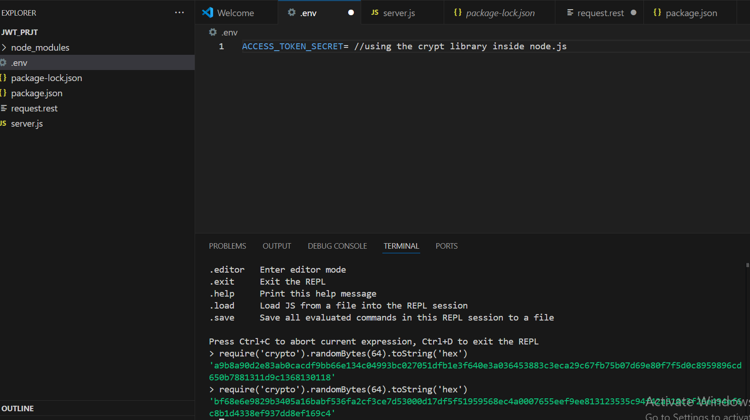

Node server seems to keep saying NOT DEFINED

